title: “UBDC CCTV blog 21 04” author: “Nick Bailey” date: “26/04/2021” output: html_document —

# The easing of lockdown in Glasgow

### Nick Bailey, UBDC - 29/04/2021

On Monday 26th April, some of the lockdown restrictions were eased in Scotland. In particular, non-essential shops were allowed to re-open, and pubs and restaurants could offer food inside and alcohol outside. Similar changes had occurred in England two weeks earlier.

In Glasgow, we can measure the impact of these changes thanks to a unique partnership between the Urban Big Data Centre, Glasgow City Council and the Glasgow Centre for Population Health. As explained in an earlier blog (<https://www.ubdc.ac.uk/news-media/2020/july/creating-open-data-counts-of-pedestrians-and-vehicles-using-cctv-cameras/>), UBDC is using spare capacity in the Council’s CCTV system to produce counts of the number of pedestrians present at a range of locations across the city.

These data are made publicly available on a daily basis, providing a near-real-time picture of footfall across the city (see details below). More importantly, processing is done using open source tools so could be easily replicated by other authorities. If you’d like more information, please get in touch!

In the figures below, we use these data to measure average daily counts of the number of pedestrians at each location between 10am and 4pm. Figures for the most recent week (in green) are compared with the averages for the same days over the previous eight weeks (in grey).

## City centre

In the city centre, we can see that footfall in the week after restrictions eased was higher than all or almost all of the previous eight weeks. We are showing four locations here but a similar story is evident with all the central locations being monitored. An initial rush on the Monday was followed by a drop on the second day of re-opening before footfall picked up again.

The one surprise is that footfall has not been as great as might have been expected, given the number of weeks for which the shops were closed. There is perhaps some hesitancy to return to the city centre and challenges in getting there, given we are still being encouraged to avoid public transport.

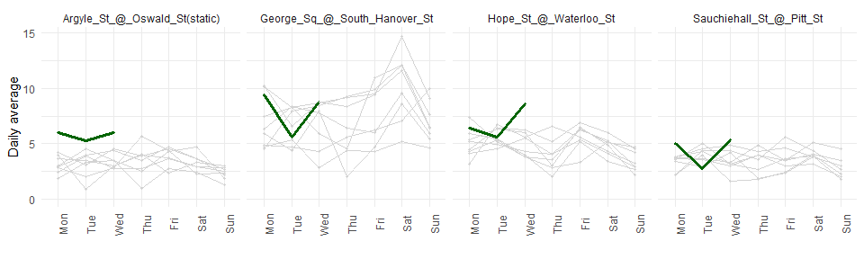

## Other high street locations

In addition to the city centre, we have data for a number of ‘high street’ locations or secondary centres such as Byres Road, Duke Street, Maryhill Road and Victoria Road. Here there is much less evidence of a rise in footfall.

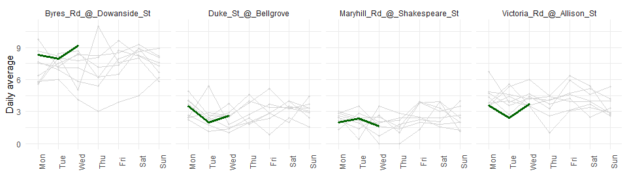

## Parks

One feature of the lockdown period has been the increased use of parks and opens spaces. With the opening up of alternatives such as shops and cafes, we might expect to see a drop in the usages of these places. That appears to be the case in Glasgow, at least for two of the largest parks - Glasgow Green and Kelvingrove.

It should be noted that the early days of easing have been marked by a drop in temperatures compared to the previous week and that might also be a factor here. But footfall is down on almost all the previous eight weeks. At last, people have other places they can be!

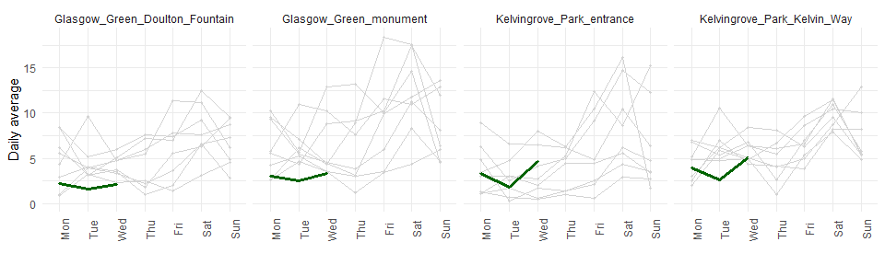

## The riverfront

Glasgow’s riverfront has also been a popular destination over lockdown for walking, cycling or just hanging out. As with the parks, footfall has been lower this week overall.

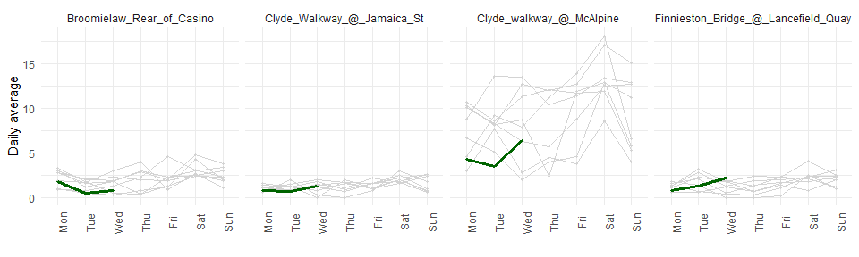

### Further information

More information on our work using CCTV to assess daily activity on city streets is available here: <https://www.ubdc.ac.uk/research/research-projects/urban-sensing-analytics/using-spare-cctv-capacity-to-monitor-activity-on-city-streets/>. Current developments include enhancements to the capture of vehicles and cycling, as well as the development of video analysis to let us capture behaviours in more detail - for example, whether people spend time in certain places or just pass through.

The data from the CCTV analysis are available here as open data: <https://api.ubdc.ac.uk/cctv/>. They are made available under an Open Government Licence. The attribution is:

“Glasgow CCTV Automated Object Detection Counts, Glasgow City Council / Urban Big Data Centre at the University of Glasgow, 2020, copyright © Glasgow City Council 2020”

The code to re-produce this analysis is available here: <https://github.com/nick-bailey/UBDC-CCTV-data>.

### Project Team

The data examined here are the result of a project involving a team of people, including:

* UBDC: Dr Mark Livingston (lead); Luis Serra; Dr David McArthur; Dr Andrew McHugh; Maralbek Zeinullin
* Glasgow City Council: Kimberley Hose; Keith Scott; Kalim Uddin
* Glasgow Centre for Population Health: Bruce Whyte